Enter your Message: lets play a game

We are about to play a game of rock, paper, scissors I can take your choice via audio(0) or image(1) input

0

Say your choice in:

3

2

1

Recording Audio

 (This is the audio input)

I choose Rock

You chose:

Scissors

I win!

Enter your Message: lets play again

We are about to play a game of rock, paper, scissors I can take your choice via audio(0) or image(1) input

1

Present choice to camera in:

3

2

1

Taking Photo

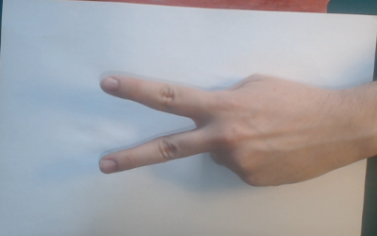(This is the image input)

I choose Paper

You chose:

Scissors

You win!